Guide: How to import KMZ files to Google Maps

**Step 1: Open Google My Maps**

* Open a web browser and navigate to [Google My Maps](https://www.google.com/maps/d);
* Sign in using your Google account if you're not already signed in.

**Step 2: Create a new map**

* To create a new map, click on Create a new map;

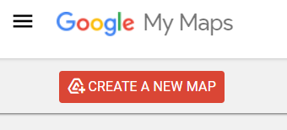 OR 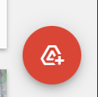

* Proceed with ‘Create’ in opened dialog.

**Step 3: Import the KMZ file**

* In the map window, look for the ‘Untitled layer’ box on the left panel;
* Click on ‘Import’;

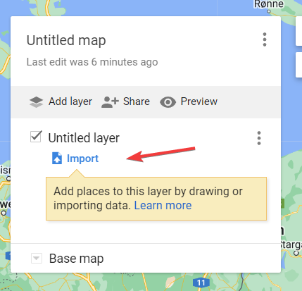

* Select your KMZ file.

**Step 4: Save the map**

* Give name for your map and save it.

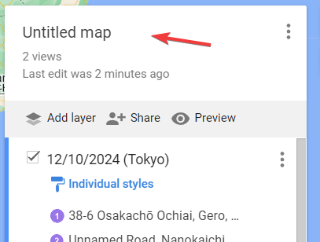 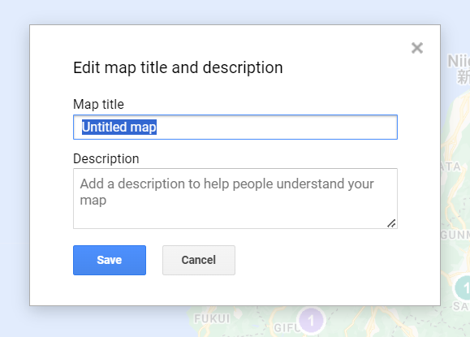

**Step 5: Open created map in Google Maps**

* Open Google Maps on your phone;
* Go to ‘You’ tab and scroll to bottom, then click on ‘Maps’;

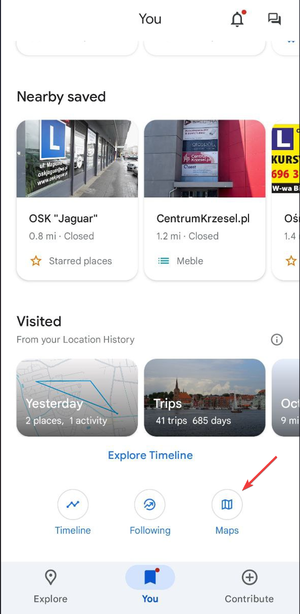

* Open recently created map, and you will see markers;

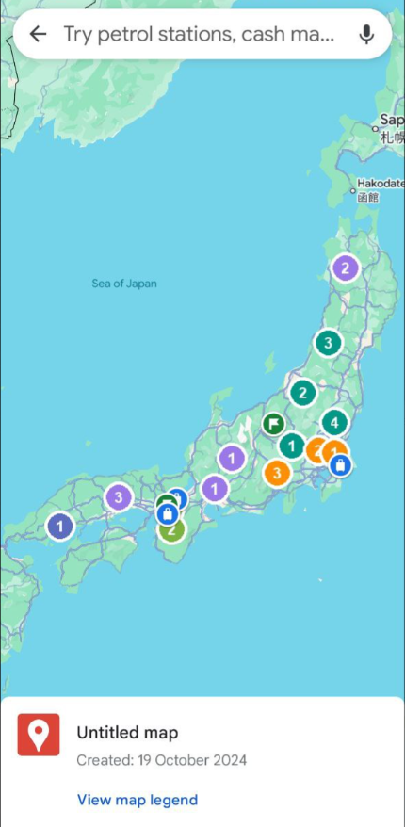

* In ‘View map legend’ you can disable markers by day;

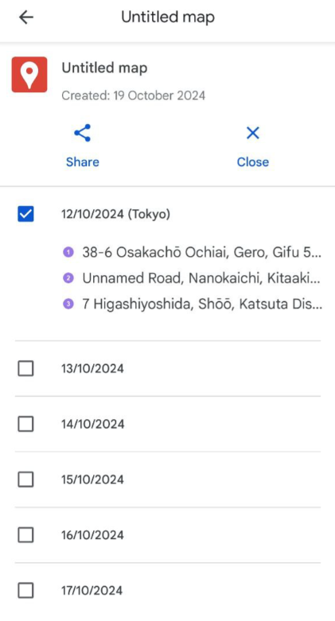

* To remove markers entirely, click ‘Close’ in map legend.